79, — The table below shows the actions of the characters and the causes of their  
actions. Fill in the blanks using information from the passage. [2m]

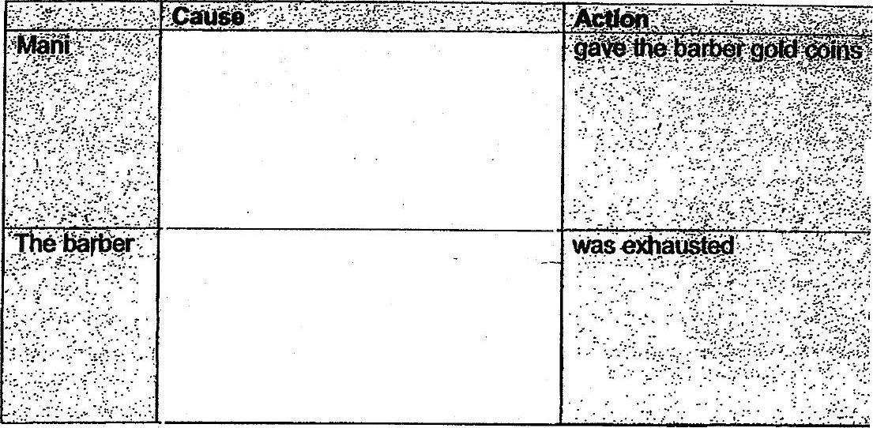

80. Do you think the judge believed Mani’s story? Support your answer with evidence  
from the passage. [2m]

™ End of Paper \*\*\*

(Have you checked your work thoroughly?)